Marketing analytics
  - PCA/FA
Digital assignment - 1
Name: Bhadri Raj T
Reg_no: 23MIA1029

- What is PCA/ FA, difference, purpose, terminologies, steps in R with rules of thumb.
- How do you interpret the following?
VIF, KMO value, Bartlett's test, Cor matrix, eigen value, scree plot, and factor loadings output of FA with example output.

1. What is pca/FA – (UnsuperVised learning)

PCA
Principal Component Analysis (PCA) is a data reduction technique that transforms many correlated variables into a smaller number of uncorrelated components called principal components.
- First component explains maximum variance.
- Second component explains next highest variance, and so on.

FA
Factor Analysis (FA) is a technique used to identify underlying latent constructs (factors) that explain patterns of correlations among observed variables.

- Assumes observed variables are influenced by hidden factors.
- Used heavily in marketing research (brand perception, product attributes, customer satisfaction).

Difference Between PCA and FA
Feature | PCA | FA
Objective | Maximize variance captured by principal components  - Identify latent factors | Model data based on underlying latent factors  - Reduce dimensions
Components | Produces principal components (linear combinations of original variables) | Produces factors (latent variables explaining correlations)
When to use | If the domain knowledge is known | If domain knowledge is unknown
Assumptions | Assumes data structure is explained by variance  - Variables should be continuous  - No extreme outliers  - No perfect multicollinearity  - Adequate sample size | Assumes an underlying factor model with latent variables  - Variables should be continuous  - No extreme outliers  - No perfect multicollinearity  - Adequate sample size
Based on | Column name | Survey
Methodology | Computes eigenvalues and eigenvectors of the covariance matrix | Models observed variables as linear combinations of factors plus errors
Applications | Dimensionality reduction, data visualization, image compression, noise reduction | Psychometrics, market research, social sciences, health sciences

Purpose
- To Reduce Number of Dimensions
  - Example: 20 product attributes → 4–5 meaningful components
- To Overcome Multicollinearity
  - Highly correlated variables cause regression problems.
  - PCA creates uncorrelated components.
- To Group Product Attributes
  - Example: Design, Color, Style → "Appearance"

Terminologies of FA/pca
- Communality: Represents how much variance of a variable is explained by the extracted factors.
- Range: 0 to 1
- Rule of thumb: 0.5 → acceptable if 0.4 not acceptable
- Eigenvalue : Represents amount of variance explained by a factor.
- Higher eigenvalue = more important factor
- Kaiser Rule: Retain factors with eigenvalue > 1
- Variance Extracted %: Percentage of total variance explained by retained factors.
- Rule of thumb: 50–70% acceptable
- VIF (Variance Inflation Factor): Used to detect multicollinearity.
- VIF = 1 → No correlation
- VIF > 5 → Moderate multicollinearity
- VIF > 10 → Serious problem
- Factor Loading: Correlation between variable and factor.
- Range: -1 to +1
- Rule of thumb:
  - 0.7 → strong loading
  - 0.5–0.7 → moderate
  - < 0.4 → weak
- Cross Loading: When variable loads strongly (>0.4) on multiple factors.
- Rule:
  - Difference between loadings should be ≥ 0.2
  - Otherwise remove variable
- Rotation: Improves interpretability of factors.
- Orthogonal Rotation
  - Factors are uncorrelated. Example: Varimax. Used when constructs assumed independent.
- Oblique Rotation
  - Factors are correlated. Example: Promax. Used in marketing because psychological constructs are often correlated.

Steps in R
KMO Value | Interpretation
> 0.9 | Excellent
> 0.8 | Good
> 0.7 | Acceptable
< 0.5 | Not suitable
Step 1: Correlation Matrix - Check if variables are correlated.
- If correlations < 0.5 → FA not useful.
- Rule: At least some correlations should be > 0.5
Step 2: KMO Test (Kaiser-Meyer-Olkin) - Measures sampling adequacy.
- Range: 0–1
- Rule: KMO ≥ 0.5 required
Step 3: Bartlett’s Test of Sphericity- Tests whether correlation matrix is identity matrix.
- H0: There is identity matrix
- H1: There is no identity matrix
- We want: p-value < 0.05 or H1 should be accepted!
Step 4: Eigenvalues
- Use Kaiser rule: retain eigenvalue > 1
Step 5: Scree Plot - Plot eigenvalues vs factor number.
- Look for: "Elbow point", Factors before elbow are retained.
Step 6: Extract Factors (PCA or FA) - Extract chosen number of factors
- Apply rotation
Step 7: Interpret Factor Loadings
- Retain variable if:
✔ Loading > 0.7 (ideal)
✔ Minimum acceptable > 0.6
✔ No serious cross loading
- Remove:
- Poor loading (<0.4)
- Heavy cross loading
Step 8: Iterative Process - Repeat until clean structure obtained.
- If problems:
- Remove weak variables
- Check KMO and loadings again
Step 9: Name the Factors - Based on common theme of variables.
- Example: Naming requires managerial judgment.
  - Comfort, Interior, Space → "Luxury"
Step 10: Compare FA and PCA
Aspect | PCA | FA
Variance used | Total | Common
Goal | Data reduction | Structure detection
Marketing usage | Multicollinearity removal | Scale development

2. interpretion
Dataset taken: df <- read.csv("diabetes.csv")
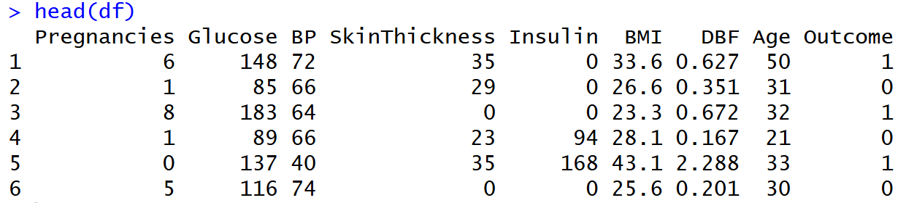
-> All datatypes are numerical
About the variables
- Pregnancies – Number of times the patient has been pregnant.
- Glucose – Plasma glucose concentration (blood sugar level).
- BP (Blood Pressure) – Diastolic blood pressure (mm Hg).
- SkinThickness – Triceps skin fold thickness (mm), indicator of body fat.
- Insulin – 2-hour serum insulin level (mu U/ml).
- BMI (Body Mass Index) – Body weight adjusted for height (kg/m²), obesity indicator.
- DBF (Diabetes Pedigree Function) – Genetic risk score for diabetes based on family history.
- Age – Age of the patient (years).
- Outcome – Diabetes status (1 = Diabetic, 0 = Non-diabetic).

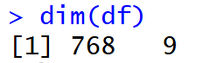
-> Has 768 records with 9 features
Summary of the data
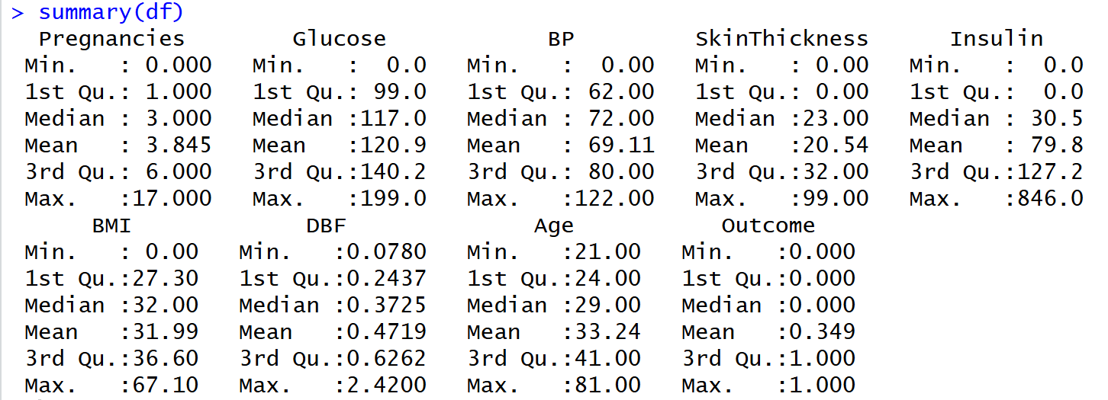
Column name
Correlation matrix - interpretion
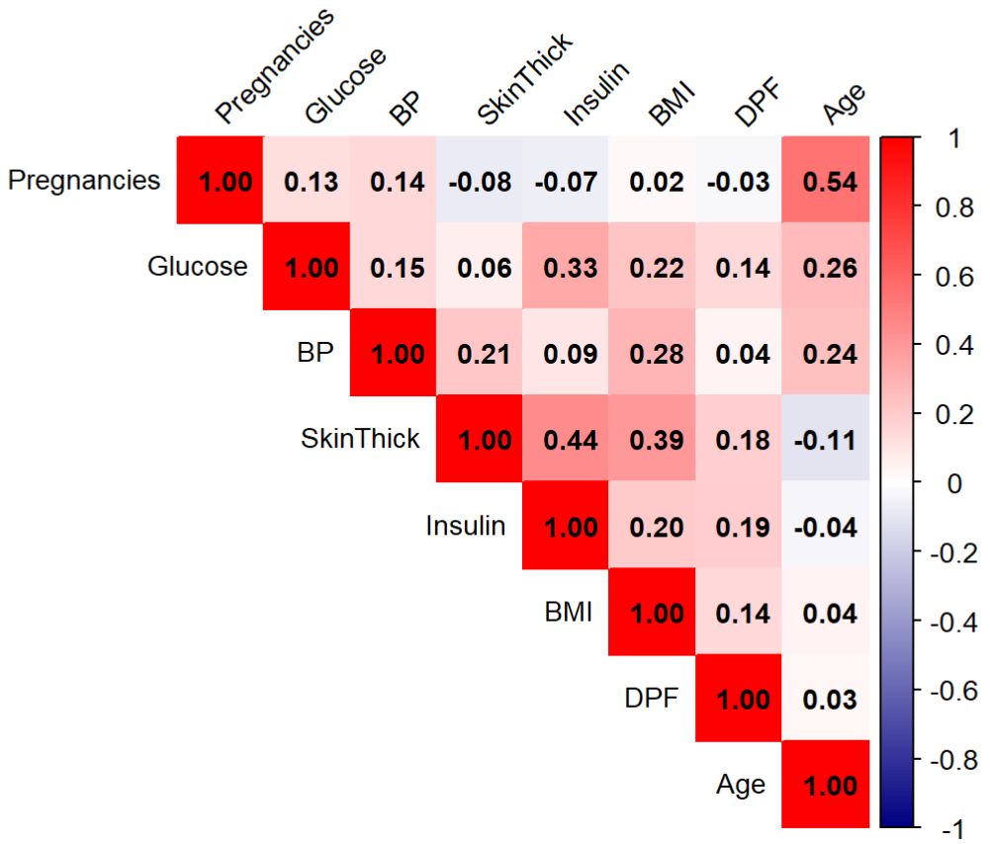
Strong Positive Correlation (r > 0.50)
Pregnancies – Age (0.54) - Strong positive relationship
-> Older women tend to have more pregnancies
Moderate Positive Correlations (0.30 – 0.50)
SkinThickness – Insulin (0.44) - Strong metabolic association
-> Higher body fat linked with higher insulin
SkinThickness – BMI (0.39)
-> Obesity indicators move together
Glucose – Insulin (0.33)
-> Higher glucose associated with higher insulin
KMO Test: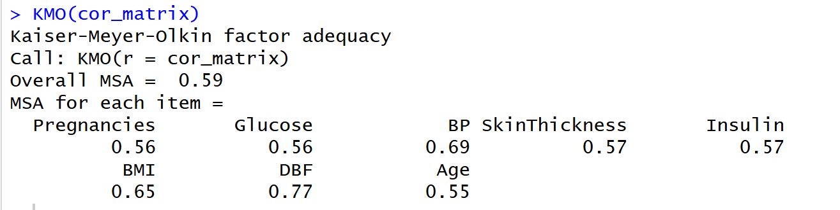
Overall MSA = 0.59 > 0.50
Sampling adequacy is acceptable - Factor Analysis can be performed
Adequacy samples - Pregnancies (0.56), Glucose (0.56), SkinThick(0.57), Insulin (0.57), BP (0.69), DPF (0.77), Age (0.55)
Bartlett’s Test of Sphericity:
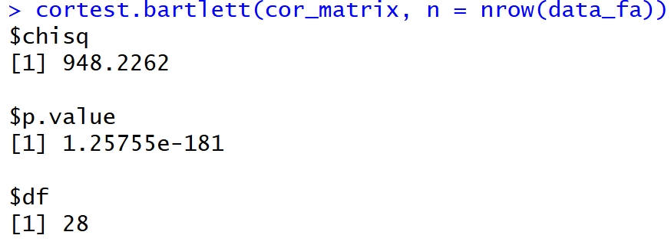
- H0: There is identity matrix
- H1: There is no identity matrix
p-value = 1.25755x10¹⁸¹ < 0.05 and Accept H1
Correlation matrix is not an identity matrix and FA can be performed.

Eigenvalues Interpretation
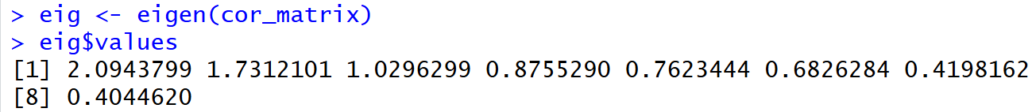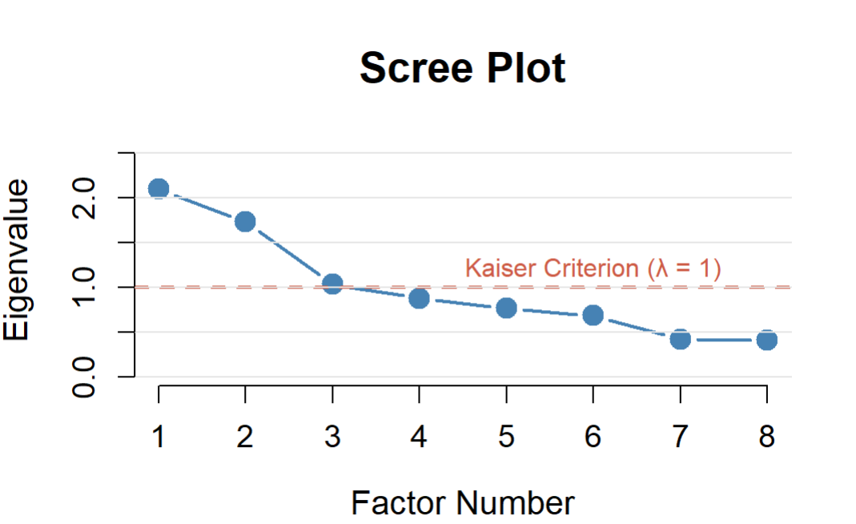
Elbow appears at Factor 3, After Factor 3, the curve flattens
-> After third factor, eigenvalues decrease slowly
-> Remaining factors contribute very little variance
Retain factors with eigenvalue > 1:
-> Factor 1 = 2.094
-> Factor 2 = 1.731
-> Factor 3 = 1.030
Remaining factors < 1 (Not retained)
Simple Logistic Regression
Since the outcome variable is Boolean in this case we will be using logistic regression
Logistic regression on each variable
H0: There is no significant impact of IV on Outcome
H1: There is a significant impact of IV on Outcome
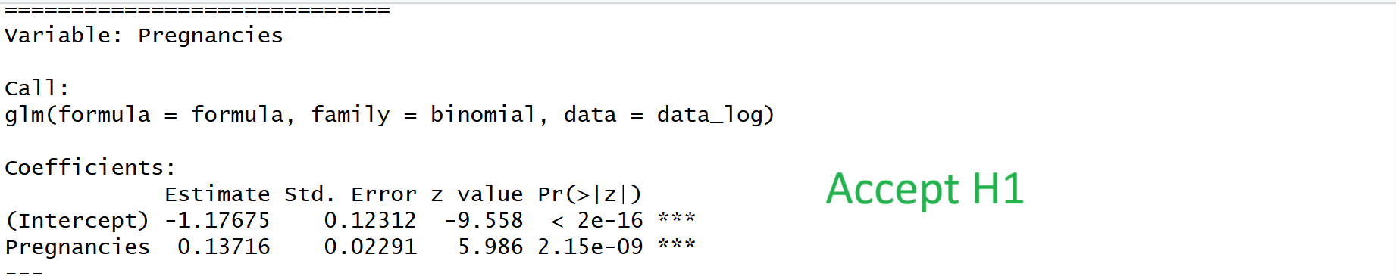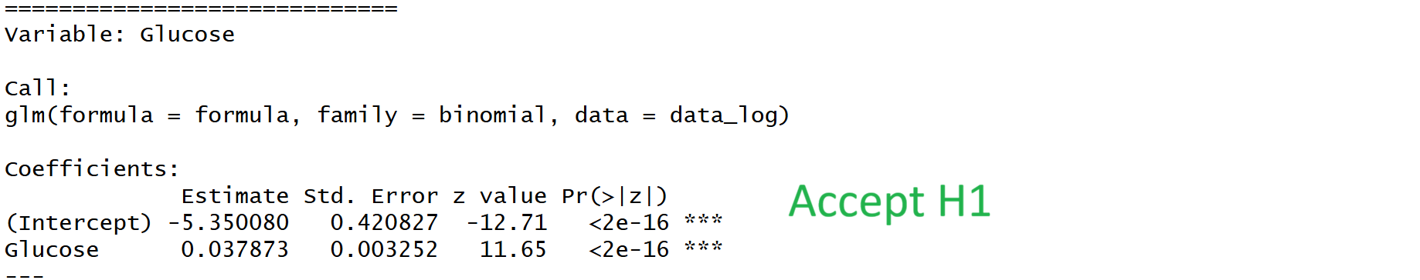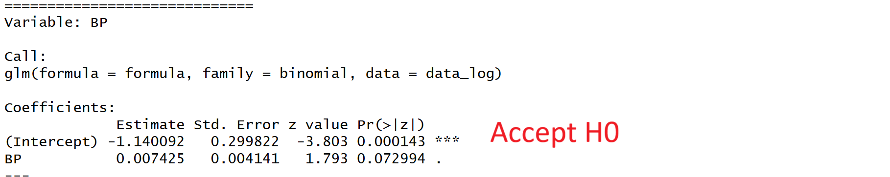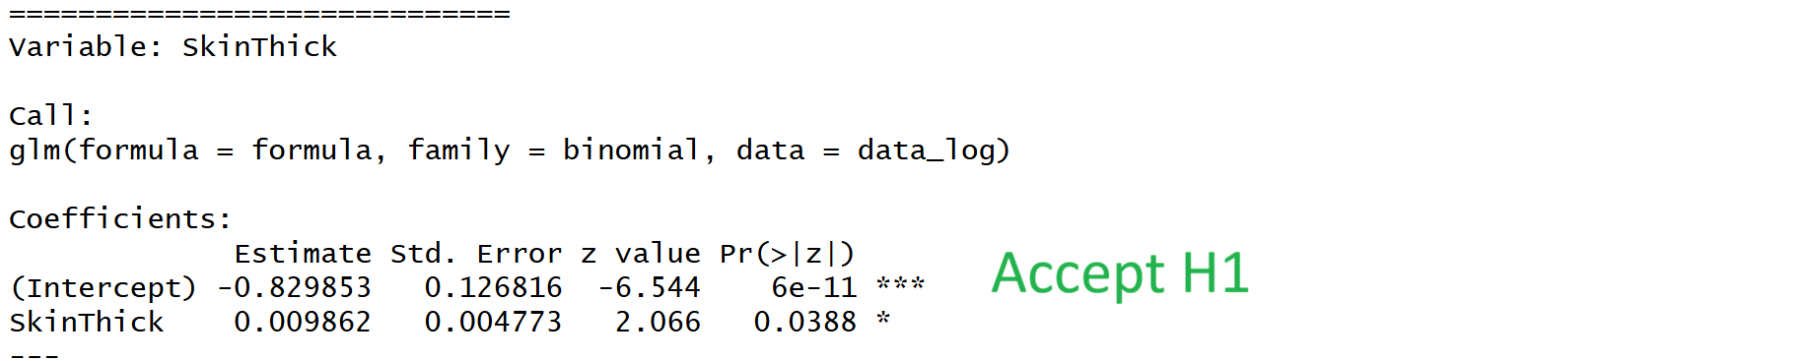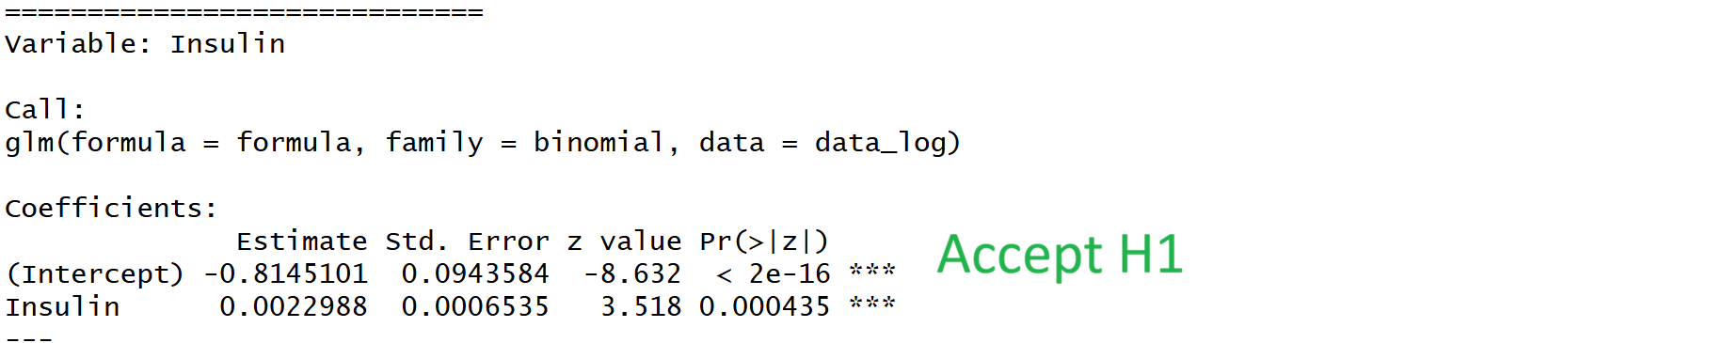
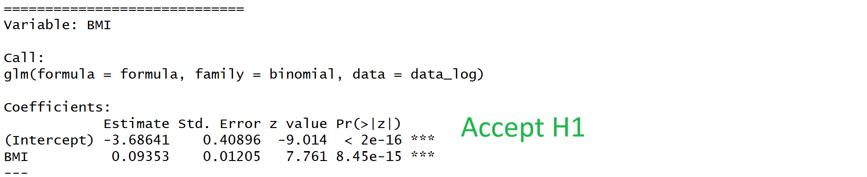 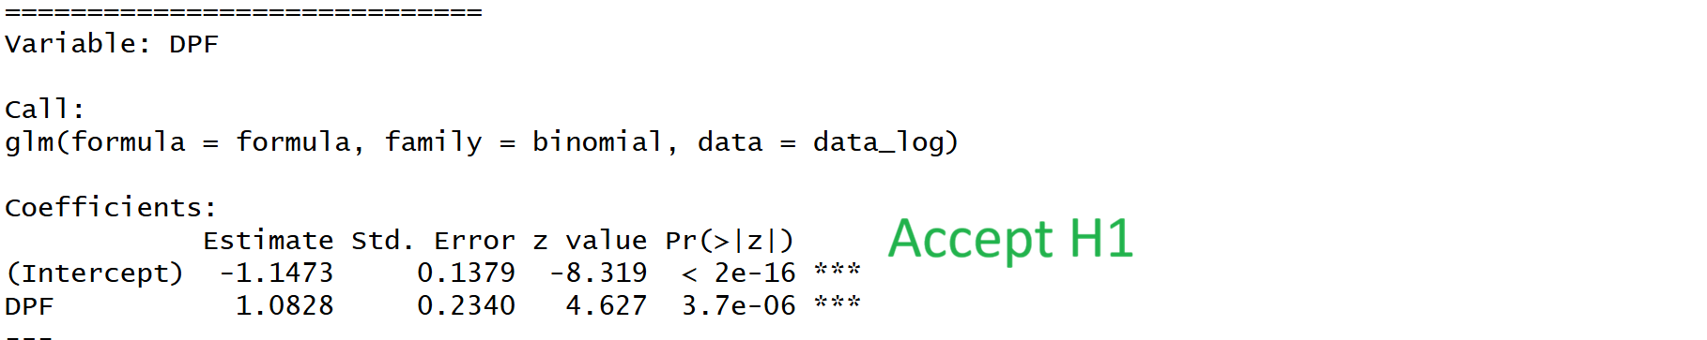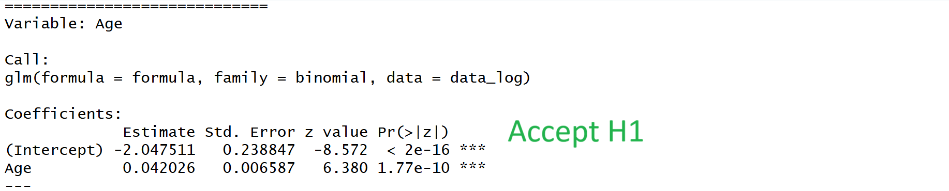In simple Logistic regression, We have BP which does not significantly predicts the outcome
Multiple Logistic Regression
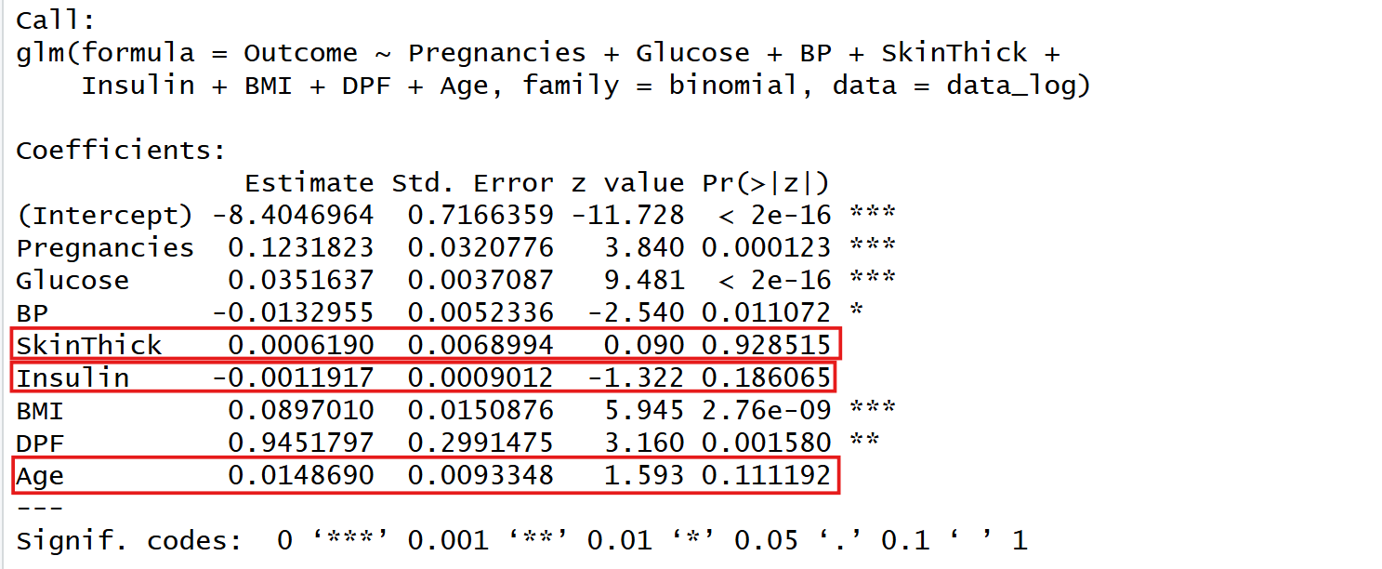
In Multiple Logistic Regression we have SkinThickness, Insulin, Age variables which are not Significantly predicting.
All VIF values are less then 3 so the variance factor is good
Factor analysis
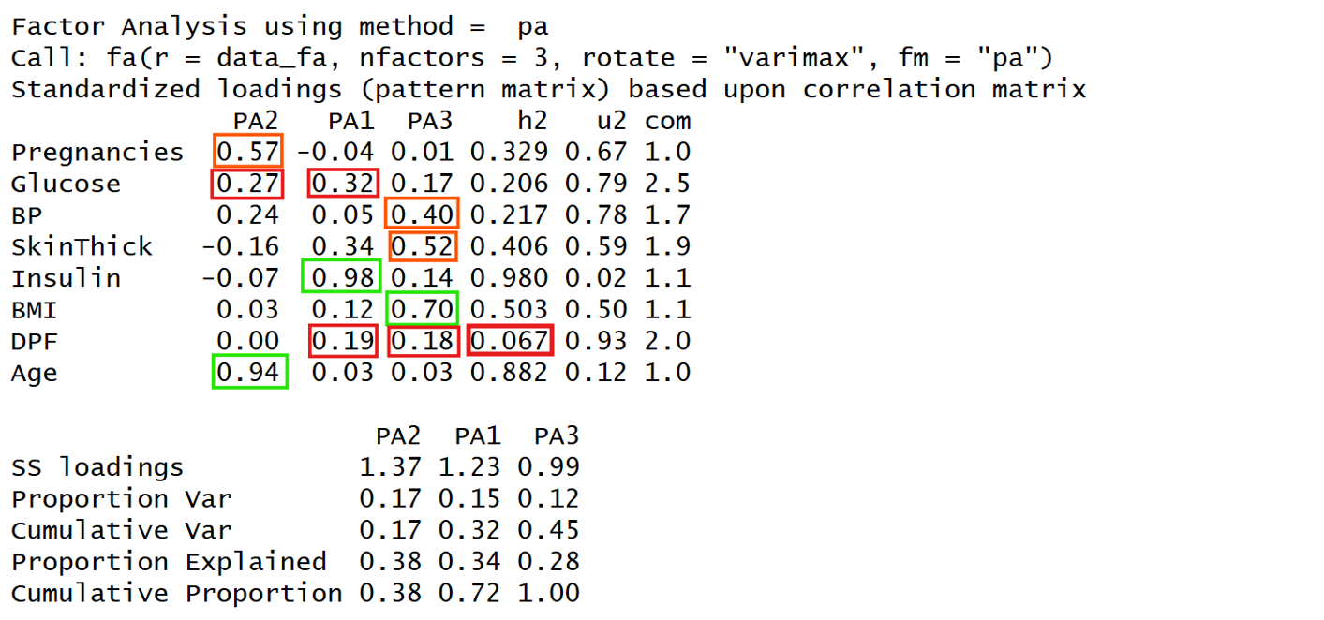
Cross loading  -> Glucose (0.32 on PA1, 0.27 on PA2)  -> DPF (0.19 on PA1, 0.18 on PA3) | Poor loading  -> Pregnancies (0.57) → PA2  -> SkinThick (0.52) → PA3  -> BP (0.40) → PA3  -> Glucose (0.32) → PA1  -> DPF (0.19) → PA1
DPF has the less communality and need to be deleted, but it Measures genetic/family risk which is moderately important factor so we go for PCA analysis
PCA
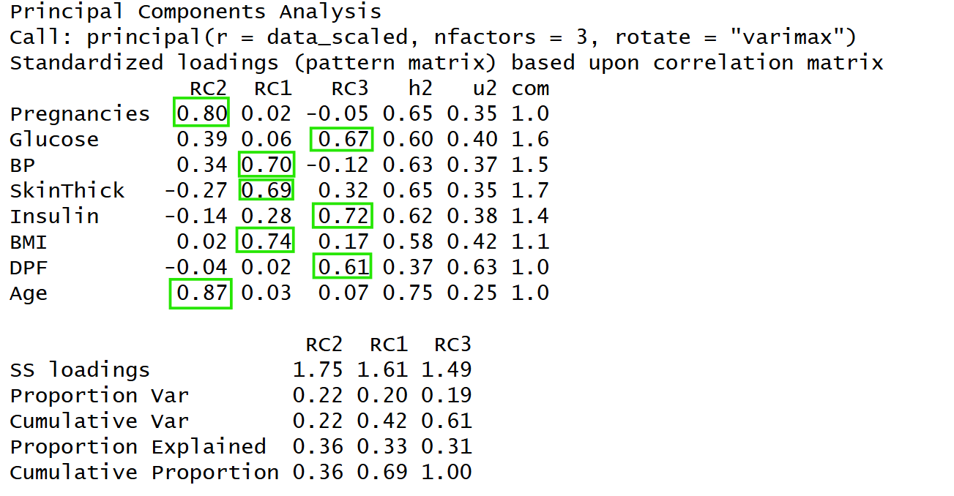
There is no poor-loading or cross-loading
Final Factors
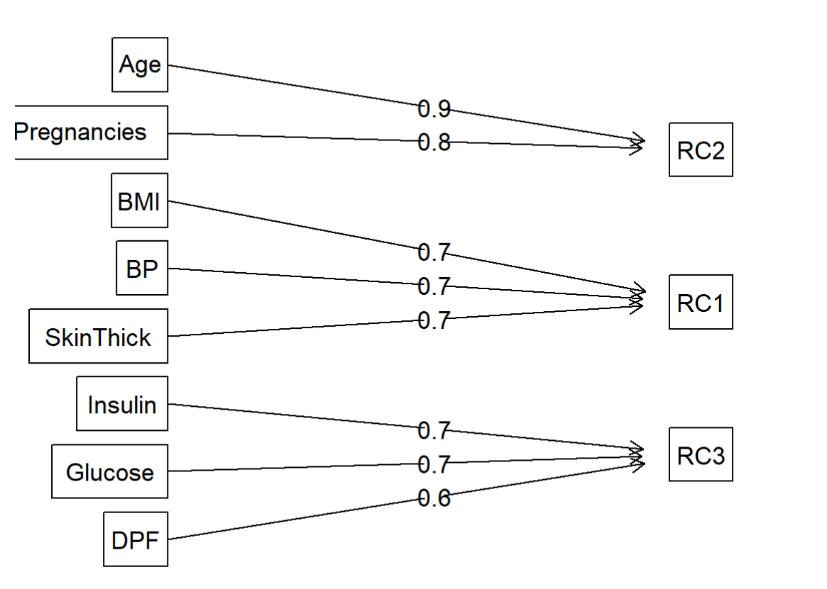
Component 1 - Obesity / Body Composition Factor
SkinThickness → RC1 (0.69)
BP → RC1 (0.70)
BMI → RC1 (0.74)
Component 2 - Demographic / Age Factor
Pregnancies → RC2 (0.80)
Age → RC2 (0.87)
Component 3 - Metabolic / Diabetes Risk Factor
Glucose → RC3 (0.67)
Insulin → RC3 (0.72)
DPF → RC3 (0.61)
Regression Test – After binding
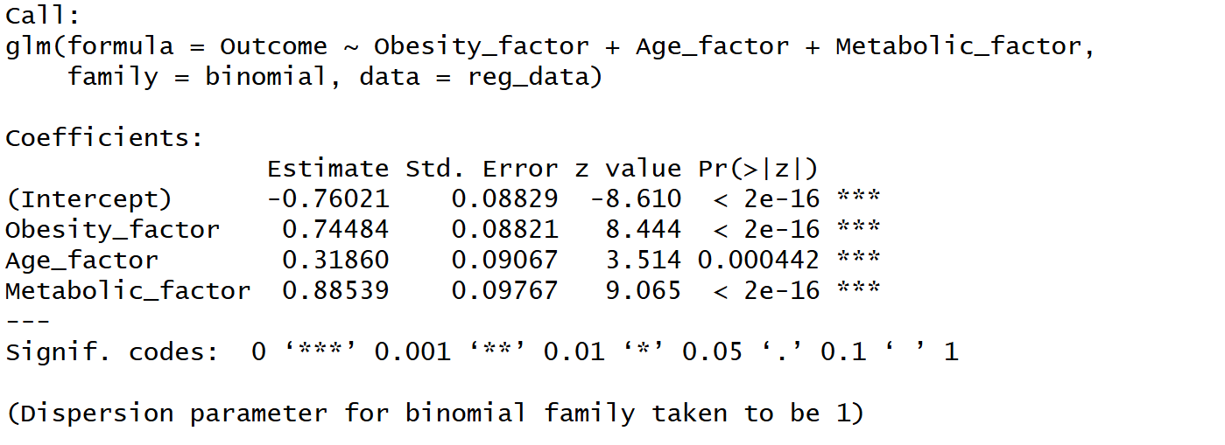
All factors are very well predicting the outcome

